**Basic Basil Pesto Recipe**

**Yield:** Makes 1 cup **Print Options**

* [Print (no photos)](http://simplyrecipes.com/recipes/fresh_basil_pesto-print/)
* [Print (with photos)](http://simplyrecipes.com/recipes/fresh_basil_pesto-print-photo/)

**Ingredients:**

* 2 cups fresh basil leaves, packed
* 1/2 cup freshly grated Parmesan cheese ( or Romano, Asiago or other hard cheese)
* 1/2 cup extra virgin olive oil
* 1/3 cup pine nuts (or walnuts or pecans)
* 3 medium sized garlic cloves, minced
* Salt and freshly ground black pepper to taste
* Several tablespoons lemon or lime juice

**Preparation:**

Combine the basil with the pine nuts, pulse a few times in a food processor. Add the garlic, pulse a few times more. Slowly add the olive oil in a constant stream while the food processor is on and scrape down the sides of the food processor with a rubber spatula several time to mix well. Add the grated cheese and pulse again until blended. DO NOT OVER BLEND! Add a pinch of salt and freshly ground black pepper to taste and the lemon or lime juice. Serve with pasta, over baked potatoes, with toasted baguette slices, crackers or just about anything you like!

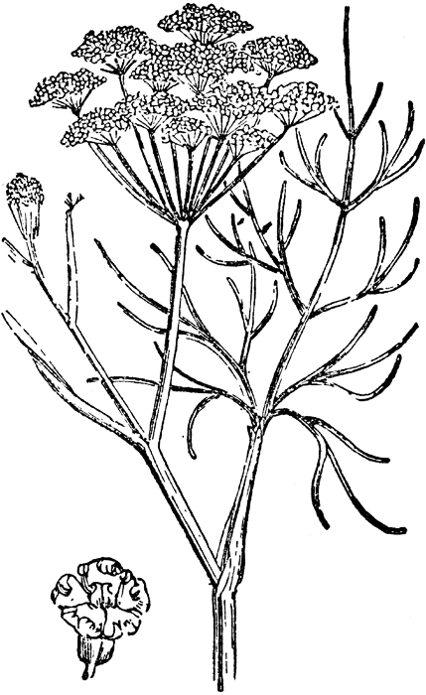

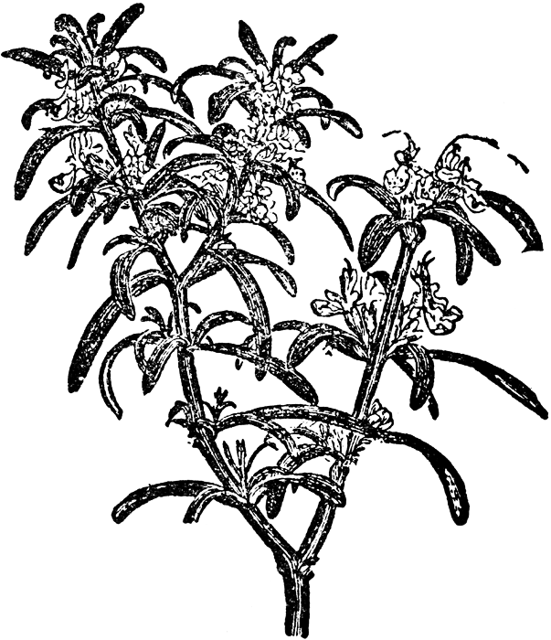

**Basil Butter**

**Ingredients:**

* 1 1/2 cups loosely packed fresh basil leaves
* 1/2 pound [butter](http://allrecipes.com/recipe/basil-butter-2/), softened
* 1 teaspoon [lemon juice](http://allrecipes.com/recipe/basil-butter-2/)
* 1 teaspoon seasoned pepper
* 1/2 teaspoon [garlic](http://allrecipes.com/recipe/basil-butter-2/) salt

In a food processor, chop basil. Add butter, lemon juice and pepper and garlic salt; blend until smooth. Drop by half-tablespoons onto a baking sheet; freeze. Remove from baking sheet and store in freezer bags. Use to flavor chicken, fish or vegetables.

**Basic Herb Butter Recipe**

Blend 8 ounces cream cheese with 1 stick butter.

Add 1/2 teaspoon Worcestershire sauce.

Blend 1 teaspoon each of garlic powder, dill, basil, white pepper and any other herb you may like to make the mix.

Add 4 teaspoons of herbs mix.



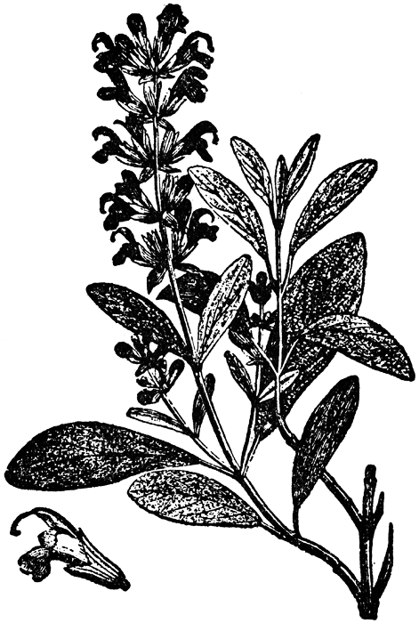





**For information about Nashville Demonstration Organic Garden (NDOG), contact**

**NDOG Coordinator**

**Gerry Wenta**

**(903) 278-6716**

**Or Howard County Farmers’ Market Manager:**

**Debra Bolding**

**(870) 557-2352**



**or check out the NDOG Page under Farmers Market on the Nashville Growing Healthy Communities Website at** [**nashvilleghc.com/ndog**](nashvilleghc.com/ndog) **.**

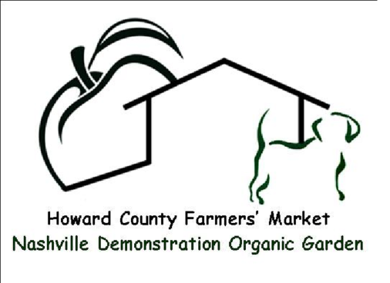

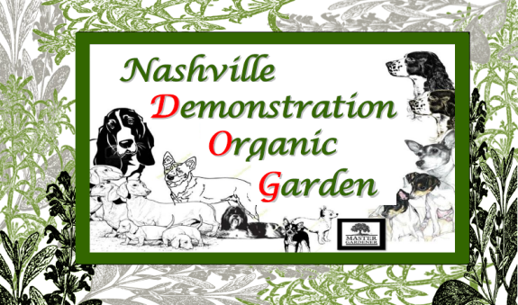

**Pesto and Herb Butter Recipes**